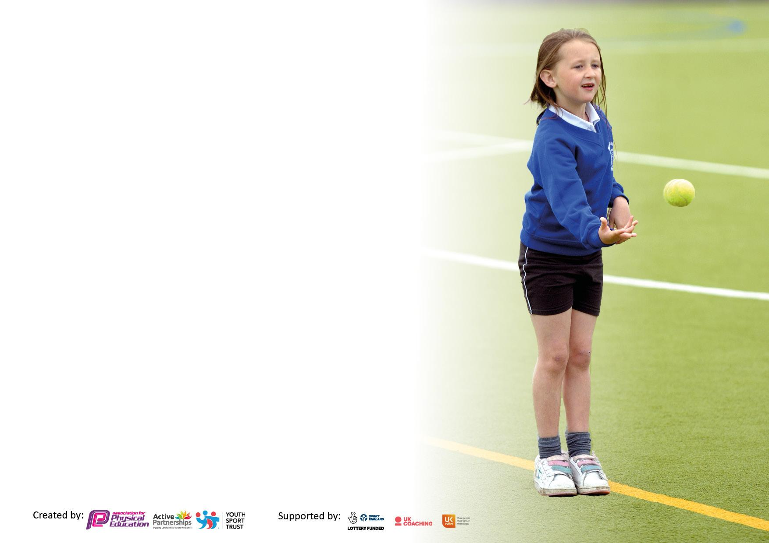

It is important that your grant is used effectively and based on school need. The Education Inspection Framework makes clear there will be a focus on **‘whether leaders and those responsible for governors all understand their respective roles and perform these in a way that enhances the effectiveness of the school’**.

Under the Quality of Education Ofsted inspectors consider:

**Intent** - Curriculum design, coverage and appropriateness

**Implementation** - Curriculum delivery, Teaching (pedagogy) and Assessment

**Impact** - Attainment and progress

To assist schools with common transferable language this template has been developed to utilise the same three headings which should make your plans easily transferable between working documents.

Schools must use the funding to make **additional and sustainable** improvements to the quality of Physical Education, School Sport and Physical Activity (PESSPA) they offer. This means that you should use the Primary PE and sport premium to:

* Develop or add to the PESSPA activities that your school already offer
* Build capacity and capability within the school to ensure that improvements made now will benefit pupils joining the school in future years
* The Primary PE and sport premium should not be used to fund capital spend projects; the school’s budget should fund these.

Pleasevisitgov.ukfortherevisedDfEguidanceincludingthe5keyindicatorsacrosswhichschoolsshoulddemonstrate animprovement.Thisdocumentwillhelpyoutoreviewyourprovisionandtoreportyourspend.DfEencouragesschools to use this template as an effective way of meeting the reporting requirements of the Primary PE and Sport Premium.

We recommend you start by reflecting on the impact of current provision and reviewing the previous spend.

Schools are required to publish details of how they spend this funding, including any under-spend from 2021/2022, as well as on the impact it has on pupils’ PE and sport participation and attainment. **All funding must be spent by 31st July 2023.**

We recommend regularly updating the table and publishing it on your website throughout the year. This evidences your ongoing self-evaluation of how you are using the funding to secure maximum, sustainable impact. Final copy must be posted on your website by the end of the academic year and no later than the 31st July 2023. To see an example of how to complete the table please click HERE.



|  |  |
| --- | --- |
| Total amount carried over from 2021/22 | £0 |
| Total amount allocated for 2021/22 | £0 |
| How much (if any) do you intend to carry over from this total fund into 2022/23? | £0 |
| Total amount allocated for 2022/23 | £17660 |
| Total amount of funding for 2023/23. To be spent and reported on by 31st July 2023. | £ 17680 |



|  |  |
| --- | --- |
| Meeting national curriculum requirements for swimming and water safety.  N.B. Complete this section to your best ability. For example you might have practised safe self-rescue techniques on dry land which you can then transfer to the pool when school swimming restarts.  **Due to exceptional circumstances priority should be given to ensuring that pupils can perform safe self rescue even if they do not fully meet the first two requirements of the NC programme of study** |  |
| What percentage of your current Year 6 cohort swim competently, confidently and proficiently over a distance of at least 25 metres?  **N.B.** Even though your pupils may swim in another year please report on their attainment on leaving primary school at the end of the summer term 2022.  Please see note above | 70% |
| What percentage of your current Year 6 cohort use a range of strokes effectively [for example, front crawl, backstroke and breaststroke]?  Please see note above | 47% |
| **What percentage of your current Year 6 cohort perform safe self-rescue in different water-based situations?** | 100% |
| Schools can choose to use the Primary PE and sport premium to provide additional provision for swimming but this must be for activity **over and above** the national curriculum requirements. Have you used it in this way? | No. May do this if we have the funding at the end of the Term. |



|  |  |  |  |  |
| --- | --- | --- | --- | --- |
| **Academic Year:** 2023/24 | **Total fund allocated:** | **Date Updated:** | |  |
| **Key indicator 1:** The engagement of all pupils in regular physical activity – Chief Medical Officers guidelines recommend that primary school pupils undertake at least 30 minutes of physical activity a day in school | | | | Percentage of total allocation: |
| 83.8% |
| **Intent** | **Implementation** | | **Impact** |  |
| Your school focus should be clear what you want the pupils to know and be able to do and about  what they need to learn and to  consolidate through practice: | Make sure your actions to achieve are linked to your intentions: | Funding allocated: | Evidence of impact: what do pupils now know and what can they now do? What has changed?: | Sustainability and suggested next steps: |
| a) All children across the school will have the opportunity to take part in a wide and varied range of physical activities throughout their designated play and lunch times. | Play leaders are appointed through applications to PE lead. These play leaders plan and run activities to engage children during play times.  Specialist coaches are utilized to lead lunch activities each lunch time. These coaches will also support the play leaders in running and evaluating their activities.  New and engaging play equipment will be purchased and will be replenished to encourage active breaks. Central resource boxes are used and updated regularly to give the children a range of equipment to use at play time.  We are purchasing a KS2 set of Moki fitness trackers to encourage classes to be as active as possible and compare their results to other classes. This data will be calculated by children to find the total physical activity of each class per week. | £0  £ 10980 for Premier Sports lunch activities.  £2200 for new equipment  £800 for Moki |  |  |
| b) Children will have opportunities to be active within lessons themselves. | The school is joining the ‘Daily Mile’ Scheme and the PE lead is in contact with the Suffolk Daily Mile Champion to develop this scheme further and benefit from Active Suffolk resources.  Active blasts have been shared with staff during CPD to encourage activity breaks within the school day. Resources to support this will be shared with all teaching staff and the effectiveness of these will be assessed through a review session at the end of the Autumn Term. | £0  £0 |  |  |
| c) Opportunities for extra-curricular participation in physical activity and competitive physical activity/sports. | A range of active clubs will be offered to children to partake in at the end of the school day which will vary across the school to offer everyone the opportunity to take part. These will be led by specialist coaches.  Use of our school partnerships and links will be used to provide a range of inter school competitions/opportunities to children this academic year including Our North Suffolk Sports partnership, links to St Mary’s and St Peters in Gorleston and our links with Premier Sports.  Intra school competitions will be run across the school in a variety of skills/sports. These will be led by PE lead and supported by specialist coaches and sports leaders. House points will be given to houses during these events. | £0  Cost of Premier Sports after school clubs  £ budgeted below.  £0 |  |  |
| d) Promote physical activity at home. | Resources and links sent home to give ideas on how to stay active at home. These will be sent in school newsletters and will be available on the school website. | £0 |  |  |
| **Key indicator 2:** The profile of PESSPA being raised across the school as a tool for whole school improvement | | | | Percentage of total allocation: |
| 3% |
| **Intent** | **Implementation** | | **Impact** |  |
| Your school focus should be clear what you want the pupils to know and be able to do and about  what they need to learn and to  consolidate through practice: | Make sure your actions to achieve are linked to your intentions: | Funding allocated: | Evidence of impact: what do pupils now know and what can they now do? What has changed?: | Sustainability and suggested next steps: |
| a) Children are aware of sporting and physical activities which are happening around the school and are able to recognise and celebrate achievements across the school. There is a culture of movement and physical activity across the school day. | An interactive PE display is up in the hall which will include PE related information, upcoming events, achievements, tips and photos.  Pupil voice will be used through surveys (to the whole school) and through feedback from school councillors. There will be termly meetings between the school PE lead and the school council to discover children’s views/needs regarding sport and physical activity and to promote the profile of PESSPA across the school.  Children will be awarded wristbands and given certificates for going above and beyond in their PE learning and physical activities around school. These will be linked to our school STAR values of: safety, trying, aspiring and respecting. These children will be celebrated in our STAR of the week assemblies in front of the entire school.  External agencies will also offer awards to children to recognise their efforts with an award ceremony at the end of the year and by giving their own wristbands to children to recognise their efforts and achievements.  We will re-launch and run the Walk to School scheme to encourage children to be active in their journeys to and from school.  Similarly, (as mentioned in Indicator 1) classes will use Active blasts to give children short active breaks in lessons. Movement breaks and using physical actions in class will be used by staff to ensure children are not still for too long. | £0  £0  £50  £0  £450  £0 |  |  |

|  |  |  |  |  |
| --- | --- | --- | --- | --- |
| **Key indicator 3:** Increased confidence, knowledge and skills of all staff in teaching PE and sport | | | | Percentage of total allocation: |
| 0% |
| **Intent** | **Implementation** | | **Impact** |  |
| Your school focus should be clear | Make sure your actions to | Funding | Evidence of impact: what do | Sustainability and suggested |
| what you want the pupils to know | achieve are linked to your | allocated: | pupils now know and what | next steps: |
| and be able to do and about | intentions: |  | can they now do? What has |  |
| what they need to learn and to |  |  | changed?: |  |
| consolidate through practice: |  |  |  |  |
| a)All school teaching staff to receive at least one PE related CPD session this academic year and receive regular support from PE Lead.  b) All teachers will receive weekly CPD in teaching PE from our specialist PE coach in one of their lessons. | The school PE Lead will use staff questionnaires to determine CPD needs, confidence levels and identify staff who would like support in planning, preparing and assessing from PE Lead.  PE Lead will lead CPD session on PE for entire teaching staff.  The school PE Lead will observe at least one PE lesson from each class each half-term and will offer support and advice as needed. All staff will be invited to observe PE lead teaching PE if desired to observe, ask questions and assess their delivery of PE. | £0  £0  £cost of premier coaching sessions |  |  |
| **Key indicator 4:** Broader experience of a range of sports and activities offered to all pupils | | | | Percentage of total allocation: |
| 9.6% |
| **Intent** | **Implementation** | | **Impact** |  |
| Your school focus should be clear | Make sure your actions to | Funding | Evidence of impact: what do | Sustainability and suggested |
| what you want the pupils to know | achieve are linked to your | allocated: | pupils now know and what | next steps: |
| and be able to do and about | intentions: |  | can they now do? What has |  |
| what they need to learn and to |  |  | changed?: |  |
| consolidate through practice: |  |  |  |  |
| A wide range of activities will be made available to children’s learning in PE and in extra-curricular clubs and activities. | Our Curriculum has been designed to incorporate a range of sports and activities including yoga and archery to offer children the opportunity to take part in as many activities and sports as possible whilst still developing the key skills/competencies set out in the national curriculum.  When purchasing new resources, consideration is given to ensuring there is a wide range of sports/activities and skills being developed across the school.  Links with specialist external agencies will help to provide specific areas to support a broader sports/physical activity offering using their knowledge and resources. E.g. ultimate frisbee or boules.  Children in Key Stage 2 will be able to develop their cycling proficiency using qualified cycling instructors to develop their road and cycling awareness.  Use of local resources such as tennis courts, local rugby club and swimming club will be used to offer a broader range of experiences to children. Building these links with the local community will provide ongoing opportunities for the children.  Orienteering package to be bought to provide children and staff the skills and resources to take part in orienteering during their learning. This will be beneficial in geography learning too and will further develop our cross-curricular links.  Children (and their adults) views will be sought when deciding upon Sports/PE clubs for each half-term to provide a variety of options linked to children’s views.  Ensuring the school offers a wide variety of clubs/competitions to children will be a priority when selecting which tournaments/events to attend.  Taster sessions for clubs such as Judo take place to ensure children know where they can participate in activity outside of school. | £0  £0  £budgeted for  £0  £0  £ 600  Get set for PE cost  £0  £1000 travel costs  £0 |  |  |

|  |  |  |  |  |
| --- | --- | --- | --- | --- |
| **Key indicator 5:** Increased participation in competitive sport | | | | Percentage of total allocation: |
| 0% |
| **Intent** | **Implementation** | | **Impact** |  |
| Your school focus should be clear | Make sure your actions to | Funding | Evidence of impact: what do | Sustainability and suggested |
| what you want the pupils to know | achieve are linked to your | allocated: | pupils now know and what | next steps: |
| and be able to do and about | intentions: |  | can they now do? What has |  |
| what they need to learn and to |  |  | changed?: |  |
| consolidate through practice: |  |  |  |  |
| 1. All children will have the opportunity to compete in competitive sport and activities outside of the usual PE lessons. 2. Children from every class will be able to take part in intra-school house competitions. | Ensure that all children are offered the opportunity to take part in school run intra-school activities representing their houses. Specialist Sports Coaches will be used to support this. Also, children’s interests and suggestions will form the activities and sports used to form these. A weekly slot will be put on the timetable to be used for intra-school competition as well as competition practice.  All classes will have inter-school competitions at least once per year.  SEN children will be offered further opportunities (in addition to scheduled year group activities) to represent the school across the school year using events organised by our Suffolk Sport Partnership.  Specialist Sports coaches will use their links to provide fixtures across the year against local schools in the area and fixtures will be set up and hosted in school. | £0  £0  £0 budgeted for within our school partnership.    £0. Cost of this has been budgeted for previously (above). |  |  |

|  |  |
| --- | --- |
| Signed off by | |
| Head Teacher: |  |
| Date: |  |
| Subject Leader: | J. Cross |
| Date: | 21/07/23 |
| Governor: |  |
| Date: |  |