**Art Vision Statement**

**Purpose and Intent**

Art is an important part of society, celebrating life and being part of a particular society. It encourages us to explore ideas and promote positive discussion around viewpoints. During their time at St Mary’s, children will learn to appreciate and critically engage with art from a wide range of cultures, people and groups.

Our curriculum is planned and sequenced so that the new knowledge and skills build on what has been taught before and towards defined end learning goals. We aim to provide as many possible cross curricular links to bring the learning alive in different dimensions and to achieve depth of learning and engagement. With all of this in mind, we make sure that our curriculum is adaptable to fit the needs of each child. We follow a Growth Mindset approach whereby mistakes are viewed as integral to learning and making progress. We develop our pupils’ resilience in the face of both academic and personal challenges.

At St Marys, we encourage children to express their view of self and the world and support them to recogonise the impact of Art on the way they experience the world around them. Through studying this subject, we promote flexible thinking, originality, imagination, precision, speed and accuracy while supporting them to develop fine motor skills.

Children at St Mary's Roman Catholic Primary school are provided ample opportunity to develop technical skills, techniques, and processes. These include drawing and painting, printmaking, collage, and sculpture.

In addition to developing the children’s love and curiosity of Art, we aim to use the study of Art to nurture and encourage their positive wellbeing and mindfulness at our school.

**Implementation**

At St Mary’s we believe that cross curricular learning is the key to immersing ourselves into a topic and to making links between subjects. With this in mind, each Art unit focuses on a project linked to the Year groups geography, history or science topics.

We follow the Suffolk Art scheme of work which has 3 units of work for each year group from Year 1 to Year 6. The units are based on the areas of experience of Drawing, Painting, Printmaking, Collage, and Sculpture.

In line with the [National Curriculum](https://assets.publishing.service.gov.uk/government/uploads/system/uploads/attachment_data/file/239018/PRIMARY_national_curriculum_-_Art_and_design.pdf) , children are expected to:

*‘Produce creative work, exploring their ideas and recording their experiences become proficient in drawing, painting, sculpture and other art, craft and design techniques evaluate and analyse creative works using the language of art, craft and design know about great artists, craft makers and designers, and understand the historical and cultural development of their art forms.’*

|  | ***KS1*** | ***KS2*** |
| --- | --- | --- |
| *National curriculum key points* | * *Use a range of materials creatively to design and make products.* * *Use drawing, painting and sculpture to develop and share their ideas, experiences and imagination.* * *Develop a wide range of art techniques in using colour, pattern, texture, line, shape, form and space.* * *Know about the work of a range of artists, describing the differences and similarities between different practices and disciplines, and making links to their own work.* | * *Create sketch books to record their observations and use them to review and revisit ideas.* * *Improve their mastery of art and design techniques, including drawing, painting and sculpture with a range of materials [for example, pencil, charcoal, paint, clay].* * *Know about great artists, architects and designers in history.* |

**Impact**

Throughout the year, teachers rigorously use assessment for learning to assess the pupils to identify gaps in their learning and adapt their teaching accordingly to meet the needs of children. At St Mary’s, we use deepening questions to challenge and extend their learning and staff provide regular live feedback so that pupils understand their next steps in their learning and know how and what they need to improve. In addition, pupils are supported in assessing their own work and in identifying targets for improvement, encouraging them to be critical thinking, independent learners.

***At St Mary’s we are STARS:*** 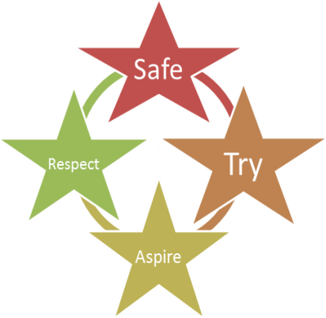

***We are Safe****- We teach children how to handle art tools to ensure they are safe both for themselves and others.****We Try****- We cultivate a growth mindset culture, valuing and recognise the effort that all pupils put into their Art lessons. We provide opportunities for all children to express themselves through art mediums, regardless of ability.****We Aspire****- We explore famous artists to provide the children with role models and to inspire them.****We Respect****- In art, we respect ourselves, others and God’s world whilst sharing ideas and developing our visions.*