**Design and Technology Vision Statement**

**Purpose and Intent**

As stated by the [D&T Association](https://www.data.org.uk/for-education/primary/#:~:text=Design%20and%20Technology%20in%20primary,to%20think%20about%20important%20issues.), Design and Technology ‘gives children the opportunity to develop skills, knowledge and understanding of designing and making functional products. It is vital to nurture creativity and innovation through design, and by exploring the designed and made world in which we all live and work’.

Our curriculum is planned and sequenced so that the new knowledge and skills build on what has been taught before and towards defined end learning goals. We aim to provide as many possible cross curricular links to bring the learning alive in different dimensions and to achieve depth of learning and engagement. With all of this in mind, we make sure that our curriculum is adaptable to fit the needs of each child. We follow a Growth Mindset approach whereby mistakes are viewed as integral to learning and making progress. We develop our pupils’ resilience in the face of both academic and personal challenges.

At St Mary’s, we encourage children to consider others and recogonise the impact their decision making has while planning and creating projects in DT. Through studying this subject, we promote flexible thinking, originality, imagination, precision, speed and accuracy while supporting them to develop fine motor skills.

Children at St Mary’s Roman Catholic Primary school are provided ample opportunity to develop technical skills, techniques, and processes surrounding the two most important aspects of Design and Technology; learning about the designed and made world and how things work, and learning to design and make functional products for particular purposes and users.

**Implementation**

At St Mary’s we believe that cross curricular learning is the key to immersing ourselves into a topic and to making links between subjects. With this in mind, each Dt unit focuses on a project linked to the Year groups geography, history or science topics.

We follow the D&T Association’s Projects on a Page scheme of work. One project is planned and undertaken each term. Children design, make and evaluate projects, developing creativity through designing skills such as generating, exploring, modifying ideas through drawing, modelling with materials and problem solving

In line with the [National Curriculum](https://assets.publishing.service.gov.uk/government/uploads/system/uploads/attachment_data/file/239018/PRIMARY_national_curriculum_-_Art_and_design.pdf) , children are expected to:

*‘Produce creative work, exploring their ideas and recording their experiences become proficient in drawing, painting, sculpture and other art, craft and design techniques evaluate and analyse creative works using the language of art, craft and design know about great artists, craft makers and designers, and understand the historical and cultural development of their art forms.’*

|  | ***KS1*** | ***KS2*** |
| --- | --- | --- |
| *National curriculum key points* | * *Use a range of materials creatively to design and make products.* * *Use drawing, painting and sculpture to develop and share their ideas, experiences and imagination.* * *Develop a wide range of design techniques in using colour, pattern, texture, line, shape, form and space.* * *Know about the work of a range of designers, describing the differences and similarities between different practices and disciplines, and making links to their own work.* | * *Create sketch books to record their observations and use them to review, revisit and evaluate ideas.* * *Improve their mastery of design techniques, with a range of materials.* * *Know about great architects and designers in history.* |

**Impact**

Throughout the year, teachers rigorously use assessment for learning to assess the pupils to identify gaps in their learning and adapt their teaching accordingly to meet the needs of children. At St Mary’s, we use deepening questions to challenge and extend their learning and staff provide regular live feedback so that pupils understand their next steps in their learning and know how and what they need to improve. In addition, pupils are supported in assessing their own work and in identifying targets for improvement, encouraging them to be critical thinking, independent learners.

***At St Mary’s we are STARS:*** 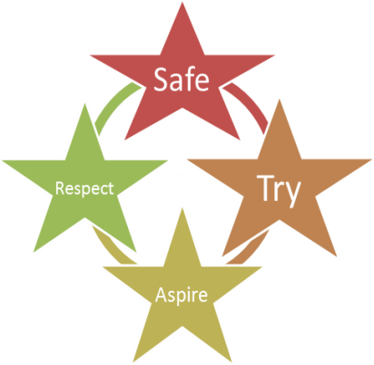

***We are Safe****- We teach children how to handle Design & Technology tools to ensure they are safe both for themselves and others.****We Try****- We cultivate a growth mindset culture, valuing and recognise the effort that all pupils put into their designs and models. We provide opportunities for all children to express themselves through design mediums, regardless of ability.****We Aspire****- We explore famous architects and designers to provide the children with role models and to inspire them.****We Respect****- In Design & Technology, we respect ourselves, others and God’s world whilst sharing ideas and developing our designs.*