Year 6 Knowledge Organiser – Evolution & Inheritance
Survival
What should I already know? | Diagrams | What will I know by the end of the unit?
Which things are living and which are not.  Identifying animals (e.g. amphibians, reptiles, birds, fish, mammals, invertebrates) and plants using classification keys.  Animals that are carnivores, herbivores and omnivores. Animals have offspring which grow into adults.  The basic needs of animals for survival (water, food, air).  Some animals have skeletons for support, protection and movement. Food chains, food webs and the role of predators and prey. | Charles Darwin, an evolutionary scientist,  stud- ied different animal and plant species, which allowed him to see how adaptations could come about. His work on the finches was some of his most famous.  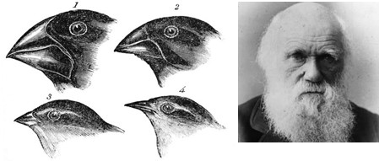  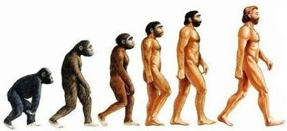  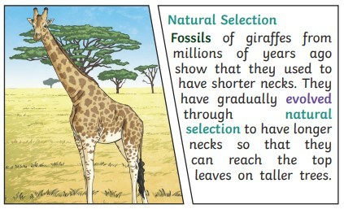  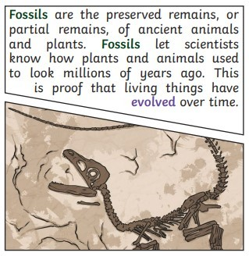 | Environment – Evolution and Inheritance  Recognise that living things have changed over time and that fossils provide information about living things that inhabited the Earth millions of years ago.  Recognise that living things produce offspring of the same kind, but normally offspring vary and are not identical to their parents.  Identify how animals and plants are adapted to suit their environment in different ways and that adaptation may lead to evolution.  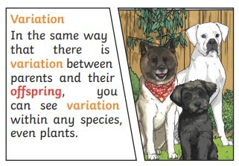  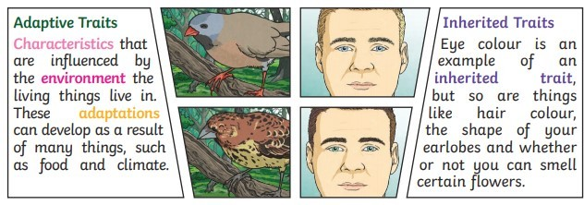
Key vocabulary
adaptation | a change in structure or function that im- proves the chance of survival for an animal or plant within a given environment.
characteristics | the qualities or features that belong to them and make them recognisable.
evolution | a process of change that takes place over many generations, during which species of animals, plants, or insects slowly change some of their physical characteristics.
species | a class of plants or animals whose members have the same main characteristics and are able to breed with each other.
mutation | characteristics that are not inherited from the parents or ancestors and appear as new characteristics.
inherit | If you inherit a characteristic you are born with it, because your parents or ancestors also had it.
natural selection | a process by which species of animals and plants that are best adapted to their environment survive and reproduce, while those that are less well adapted die out.

Topic-Survival Evolution & Inheritance

Question 1. A gradual change that takes place over many generations is called: | Start of unit | End of unit |  | Question 4. When we have the same characteristic as our parents or ancestors, we that characteristic. | Start of unit | End of unit
A. inheritance |  |  |  | A. have inherited
B. mutations |  |  |  | B. have mutated to get
C. evolution |  |  |  | C. have adapted to
D. reproduction |  |  |  | D. have maladapted to
Question 2. Evolution occurs when there is competition to survive. This is called… | Start of unit | End of unit |  | Question 5. The dodo was unable to adapt to its environ- ment to survive. This means that the dodo is now… | Start of unit | End of unit
A. reproduction |  |  |  | A. extinct
B. natural selection |  |  |  | B. endangered
C. variation |  |  |  | C. alive
D. biodiverse |  |  |  | D. flying
Question 3. Evidence of evolution comes from…(tick two) | Start of unit | End of unit |  | Question 6 Charles Darwin… | Start of unit | End of unit
A. fossils |  |  |  | A. found the first fossil
B. living things |  |  |  | B. was made famous by his theory of evolution
C. museums |  |  |  | C. found remains of the dodo
D. food chains |  |  |  | D. Don’t know

