|  |
| --- |
| **Classification Knowledge organiser** |
| **The 7 Levels of Classification**  Today we use 7 different levels of classification. These are as follows:    Kingdom (Keeping)  Phylum (Precious)  Class (Creatures)  Order (Organised)  Family (For)  Genus (Grumpy)  Species (scientists)  An example of how humans are classified, you will see that our species is homo sapiens. |
| **Microorganisms**  [Image result for microorganisms](https://www.google.co.uk/url?sa=i&rct=j&q=&esrc=s&frm=1&source=images&cd=&cad=rja&uact=8&ved=0ahUKEwjVoszEzb3RAhXMfxoKHd6yARwQjRwIBw&url=https://simple.wikipedia.org/wiki/Yeast&bvm=bv.144210762,d.ZWM&psig=AFQjCNEoMReLVYtyvDtnzOk3w6nlCVZfjA&ust=1484344796539227)If you can only see a living thing with a microscope, it means it is a microorganism. These are found everywhere. Some of them, like yeast are helpful whilst some of them are harmful and disease causing, like bacteria. It is important to know how to avoid spreading the bad ones. (Wash your hands!)  **3 Types**   * Viruses * Bacteria * Fungus |
| Image result for carl linnaeusIn about 350 B.C. Aristotle (a Greek philosopher) classified all things into 4 main groups.  **Carl Linnaeus** then simplified the naming of living things in 1735. Names of living things were often very long so he gave them a two-part (binomial) name. It was a mixture of genus and species (and in Latin) e.g. Human was Homo Sapien, |

|  |  |
| --- | --- |
| https://lh5.googleusercontent.com/QzPzgoCesOZDqXWgok_UbEm5Shc-MlXL2ljOU6jCHa4hAkZH_2bVkTl7b4-CwruUzMs9Pq_LhIhWHsqCvXsbdI9fD8JygR1nlUVfPOPWh30LMoDR5J1y7Q_XzbIwCp7WjQ0wBcK0 | **Key vocabulary** |
| **Antennae** | Flexible limbs growing out of the head which have sensory organs for touch, smell and taste (‘feelers’). |
| **Arachnid** | An arthropod with eight legs and no antennae or wings. |
| **Arthropod** | An invertebrate with a hard, external skeleton and with jointed limbs. |
| **Crustacean** | An arthropod with two pairs of antennae (eg. woodlice, shrimp). |
| **Insect** | An arthropod with six legs which can be wingless or have up to two pairs of wings. |
| **Myriapod** | An arthropod with a long, flatbody (centipede) or a cylindrical body (millipede) with one pair of antennae and many legs. |
| **Cephalopod** | Means ‘head foot’ – the group octopuses and squids belong, a subgroup of molluscs (meaning ‘soft body’). |
| **Species** | A group of living things which have a large number of similarities and few differences and the males and females are able to breed and produce offspring which can also breed. |

|  |
| --- |
| 3 new facts: |
| ______________________________ |
| ______________________________ |
| ______________________________ |

Kingdoms

Scientists have now divided living

things into five larger

groups called Kingdoms.

**1.) Plants**

**2.) Animals**

**3.) Fungus (mushrooms, yeast, mould, mildew)**

**4.) Protist (protozoans,**

**amoeba, euglena)**

**5.) Prokaryote**

**(blue-green algae,**

**bacteria)**

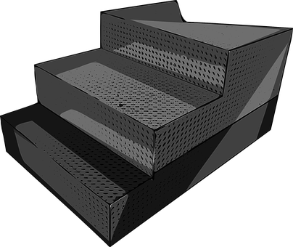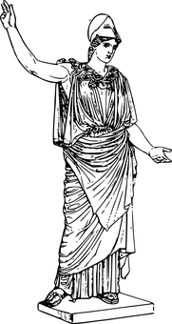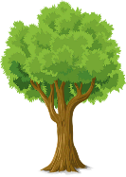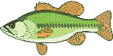

***Human Beings***

***Animals (cats and fish)***

***Plants (trees and grass)***

***Non-Living (rocks)***